Appendix 6: New Features in Version 3.4
Here is a brief listing of some of the features new in Version 3.4:
General Operation:
- The program now requires you to 'Allow' it to run in Vista and Windows 7 (same as right click on desktop icon, then select 'Run As Administrator'). This should make the program more Vista and Windows 7 compatible.
- You can now save a graphics picture file with engine data, which could be a picture of your car or engine. This picture appears on the main screen, and can be printed out with graphs and reports, or just separately from the main screen. Fig A 9, A 23.
- We’ve added a global switch to turn Off or On the Intro Help Tips in Preferences. Fig A 24.
Short Block:
- We’ve added hundreds of combinations of bore, stroke and rod length examples.
- We’ve increased the size of the Comments box for all components, to allow you to better describe your changes. This is common to all Component Screens. Fig A 24.
Heads:
- We’ve added the ability to import flow files from Port Flow Analyzer. Plus version only.
- You can now import head files from some Desktop Dyno (tm) and Dyno Sim (tm) programs and those available from Stan Weiss, .flw and .dfw files. Fig A 14, A 19.
Intake/Exhaust:
- A picture explaining the definition of primary pipe length and collector length is available in the Exhaust System Specs screen.
- The program now shows pictures of intake manifold and exhaust manifold/header types, to more clearly explain the choices.
Cam/Valve Train:
- We’ve added a new screen to let you do Variable Cam Timing (VVT). Plus Version Only. Fig A 13.
- Dwell over Nose (Cheater profile) can now be more exactly defined, to the nearest 2 degree increment. Also, now this setting can be different on the intake vs the exhaust. Plus version only. Fig A 14.
- The program now allows for using a Ramp Rating for the cam profile for more exact cam profiles. There is also a ‘Clc’ screen to calculate the ramp rating to match certain duration specs at either .200 lift or seat timing. Plus version only. Fig A 14, A 15.
- We’ve added hundreds of new Example Cam Categories (especially Imports and Motorcycles) and cams themselves. Many are stock engine cam files from John Holm. Many thanks John.
- The screen for opening std Engine Analyzer Example components now let you select to only show components which match up to 3 criteria you have selected at the bottom of the screen. Fig A 16.
- We’ve added option to import Other Format Files for Cam files, like .cam and .scm files from Desktop Dyno (tm) and DynoSim (tm). Fig A 18.
- The screen for opening Example Cams now show the Gross Valve Lift and Lobe Separation for the cam you selected if you right click on the selected cam. Fig A 16.
- We’ve added an “Optimize Using These Cams” button in the Example Cams screen. The program will run each cam you’ve selected in the Example Cams screen and display the 4 cams which best meet your “Optimize” criteria. Fig A 16, A 17.
- When you change Lobe Separation in the Cam Specs screen, now the program adjusts the centerlines correctly.
- We’ve added a “Clc” button for Lobe Lift being calculated from Gross Valve Lift and Rocker Arm Ratio. We’ve also added a “Clc” button for Lobe Separation. Fig A 15.
- Cam Advance can now go from 30 Retard to 30 Advance
- We’ve made some refinements to the Cam Profiles created by the EA Pro to more precisely time them to the nearest 0.1 deg.
- We’ve added .053" lift for rating events (like Harley Davidson cams). Fig A 14. Turbo/Supercharger:
- The Roots Supercharger type now allows for an Intercooler. Fig A 19. Calculation Conditions:
- Program now has Fuel Option of E85. Plus Version Only. Fig A 20.
- Program now displays the Typical Octane for various fuel types. Fig A 20. Calculations:
- We’ve increased the Piston Speed limit above which program says is Impossibly High because materials and technology have made huge strides over recent years.
- Idle vacuum now more precisely estimated for super/turbocharger type and size.
- The program now better checks for blank inputs before doing calculations. ASCII Data Files:
- We’ve added a Browse button to screen for writing ASCII files of test results. Fig A 21.
- We’ve added an option to include the Special Calculations section for writing ASCII files of test results. Plus Version Only. Fig A 21.
Graphs:
- Program now has an “Edit Printed Graph” command under Format. It opens a screen where you have several options on how to print your graph, include various comments, etc. You can now select to include the torque and HP data in a table when you print out RPM data graphs as long as there are torque and/or HP data on the graph. Plus Version Only. Fig A 22, A 23.
- Program now has larger Legend Text sizes available (under Format) on graph screen. Fig A 23.
- Program now prints cursor and cursor values when you print a graph. Fig A 23.
- We’ve added additional graph scale multiplier for Special Graph types of x 1000. Printouts:
- We’ve refined the printouts to look better and be more compatible with more types of printers. Fig A 23.
- The program now better remembers Printer Changes and Printer Type.
- You can now print a Company Logo graphics files on reports and graphs. This info is loaded in the Preferences screen. You can specify 2 lines of text which can appear at the top of printouts
of reports and graphs in the Preferences screen, under Printing/Graphing. Plus version only. Fig A 23, A 24.
- The program is now better at finding more versions of Acrobat and Reader for a printer choice.

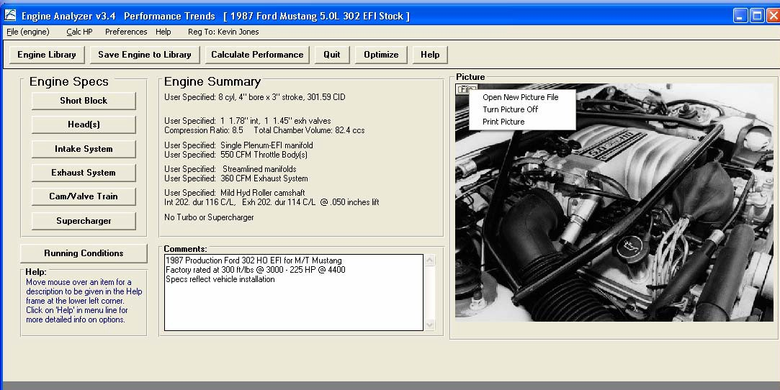
Figure A 9 Main Screen Showing Engine Picture
Click on File for options to pick a graphics file, and other options.

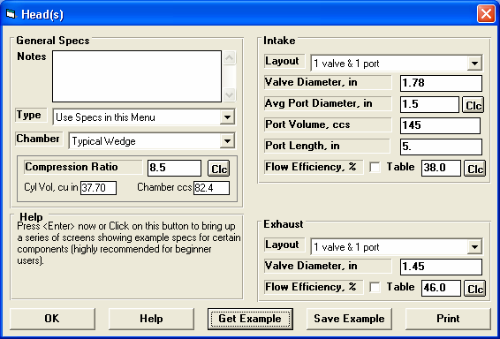
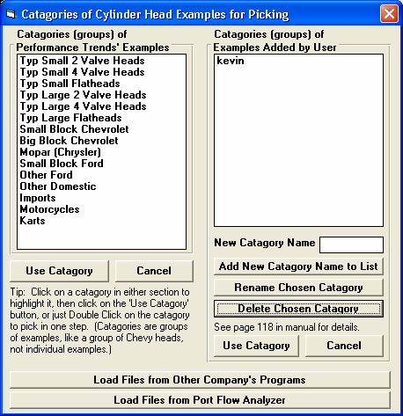
Figure A 10 New Feature for Picking Example Component Files
Click on this button to bring up the screens shown in Figure A 12.
Click on this button for the screens shown in Figure A 11.
Pick a Category from either group (side) and click on the Use Category to open the screen for picking a component. See Figure A 16.
Click on Get Example button to bring up the screen for picking a Category of component example files.

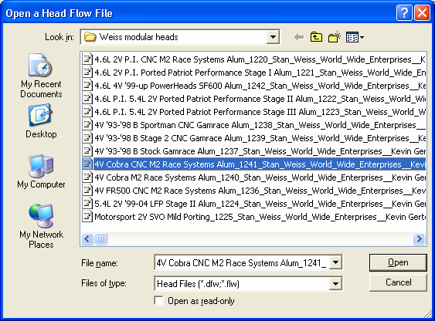
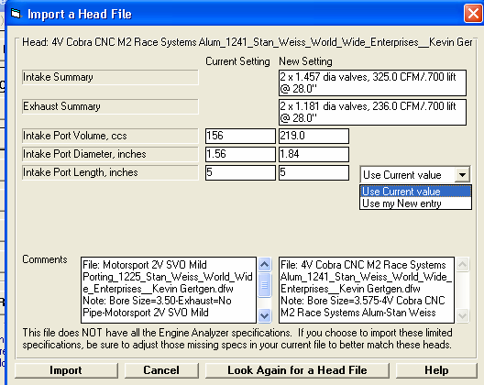
Figure A 11 Importing Head Files from Other Company’s Programs.
Click on Open to pick the file you’ve highlighted.
Std Head File extensions to look for.
Click here to import these specs.
If the file included port volume (Weiss files only), you can choose to use the current Port Length for calculating Avg Port Dia, or choose to enter your own port length.
This screen shows a comparison summary between new file selected and the existing head on your current engine (shown in left column).
Use this standard Browse screen to find the Head Files with “.dfw” or “.flw” extensions.

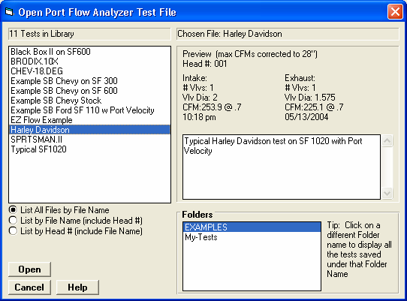
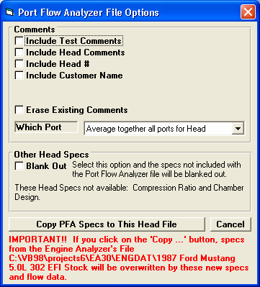
Figure A 12 Importing Head Files from Performance Trends’ Port Flow Analyzer (Plus Version Only)
Check the options you want, choose which Port (or Average all ports Together), and click on the “Copy PFA Specs to This Head File” button.
Find the file, then click on the Open button for the screen below.
You get this screen by clicking on the “Load Files from Port Flow Analyzer” button shown in Fig A
10. This screen is very similar to the File Open screen in your Port Flow Analyzer. Use it to choose the file you want to load.

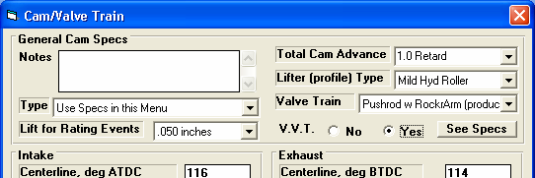
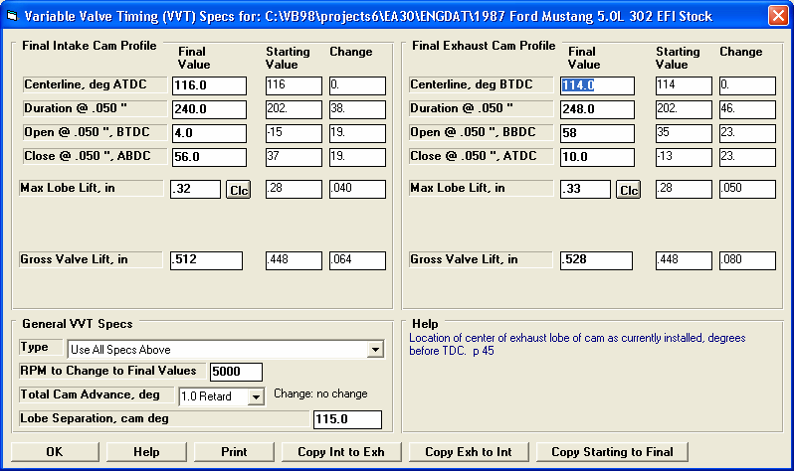
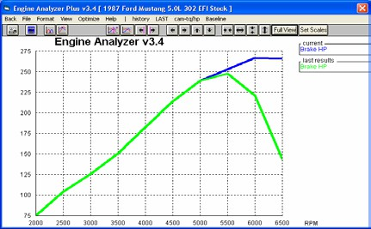
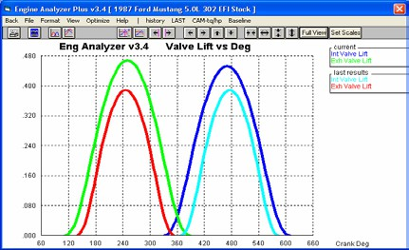
Figure A 13 Variable Valve Timing (V V T) Specs (Plus Version Only)

These are the settings from the original Cam Specs screen, shown for
This column shows the “Change” (difference) between the Starting Value and the Final Value.
At 5000 RPM and higher, bigger VVT cam makes more power
Bigger VVT
Cam
Click here for more details on how this screen works.
Enter the RPM at which the program should switch from the specs on the original Cam Specs screen to these VVT
Your choice here determines which specs are enables on this screen.
Enter the values you want to use at and above the “RPM to Change to Final Values” input in lower left
Choose Yes, and then you can click on the “See Specs” button to see screen below.

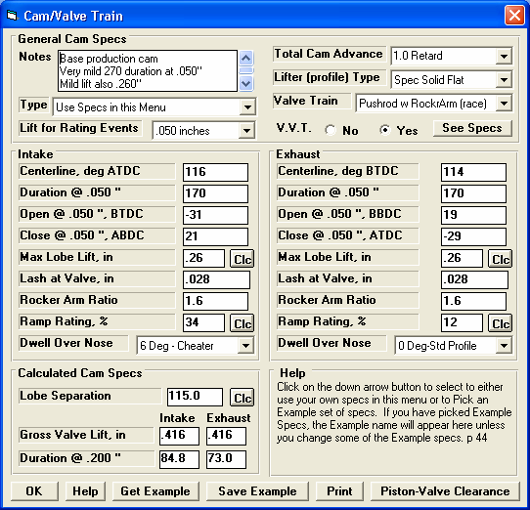
Figure A 14 New Features in Cam/Valve Train Screen
New “Clc” option for Lobe Separation. See Figure A 15.
Std Version lets you pick std (no dwell) or Typical Cheater (lots of dwell). Plus Version lets you fine tune this in 2 degree
New “Clc” option for Max Lobe Lift.
Ramp Rating is displayed if you choose “Spec” (user specified) profile type in upper right corner. Click on the “Clc” button to calculate from 2 duration specifications (Figure A 15).
New VVT specs as shown in Figure A 13.
New “Spec” (specified) profile option displays Ramp Rating input below for you to “fine tune” the ramp. Plus Version only.
Larger Notes box to allow for more comments (same in other screens).
“Cheater” profiles are gone, replaced by Int and Exh “Dwell Over Nose shown below.

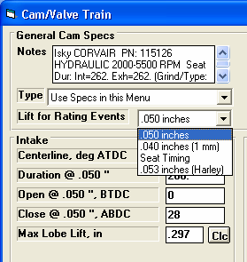
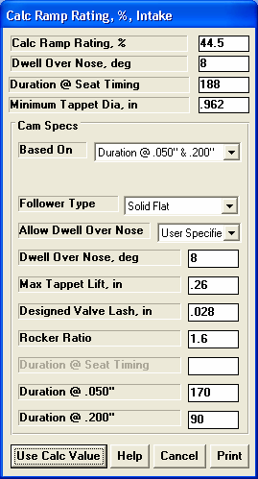
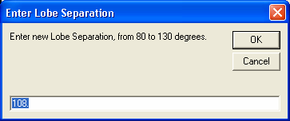
Figure A 15 More Cam/Valve Train Specs Screen Features
Simple “Clc” screen to let you change lobe separation.
Program will change both centerlines the same amount to keep the Total Cam Advance or Retard the same.
You can now choose the Harley Davidson lift spec for rating events of
.053” tappet lift.
You can calculate an exact Ramp Rating for a “General Description” or to match 2 specific duration inputs by your choice of “Follower Type”. Four (4) calculated outputs describing the resulting profile are shown at the top of this screen.

Figure A 16 New Features for Picking Example Components, Many Especially for Cams
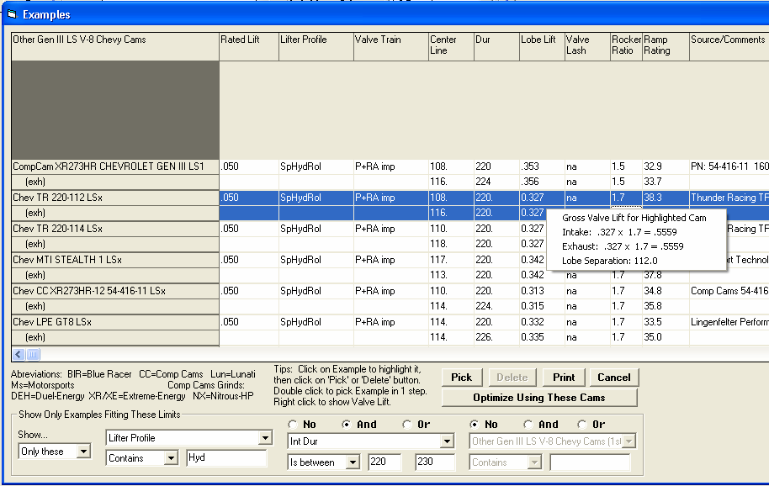
Several Examples are NOT shown because they do not meet the criteria you set in the “Show Only Examples Fitting These Limits” section described below.

Plus Version shows Ramp Ratings for Cams, if available.

If you right click on a Cam you have picked (which will be highlighted in blue as shown here), several calculated parameters for that cam are shown.

Click on this button (only available for example Cams) and the program will optimize trying each example cam shown. See Figure A
In this section, you can choose to Show… ‘All Examples’ or ‘Only These’ as shown. Then you can use the 3 groups of conditions to determine what examples are shown. For example, in this screen, we have picked to only show cams with the phrase “Hyd” in the Lifter Profile description and an Intake Lobe Duration from 220 to 230 degrees. Now this screen will only show you Hydraulic cams with an intake duration at .050” from 220 to 230 degrees. This feature is available for all components.

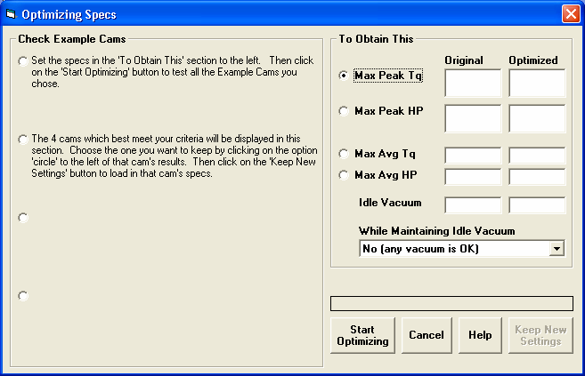
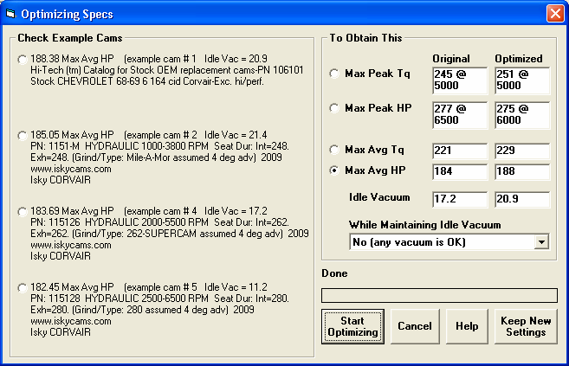
Figure A 17 Optimizing Example Cams, as Described in Figure A 16
The program will show the 4 best cams which meet your criteria. Pick one of these 4 using the round option button, then click on the “Keep New Settings” button to load in this Example Cam.
If you click on the “Optimize Using These Cams” button as shown in Figure A 16, instructions for using this screen are displayed here.
Basically you pick what you want to optimize (Max Peak Tq, etc), pick an Idle Vacuum level, and then click on the Start Optimizing button.

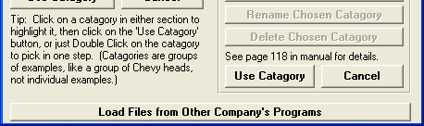
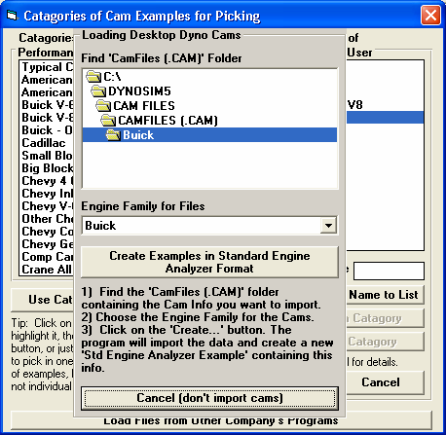
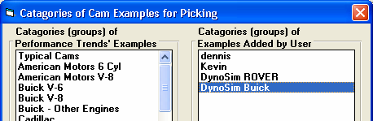
Figure A 18 Loading Cam Files from Other Company’s Programs
When finished, you will have a new Category in the “Examples Added by User” section. Now you can open up this Category to see all the Cams and use all the features as described in Figure A 16.
Click on this button to start importing All these cams. This process may take several minutes.
Choose the Engine Family for the Cam Files you want to import. Note, many times this may be the same exact name as for the folder. However, if you chose the folder Chevy, you may want to only import for the Engine Family “Small Block Chevy”
Use this section to Browse to the folder containing the Cam Files you want to import.
If you are picking a Category of Example Cam File (screen shown in Figure A 10), you have this Option button. If you click on it, you get the screen shown below.

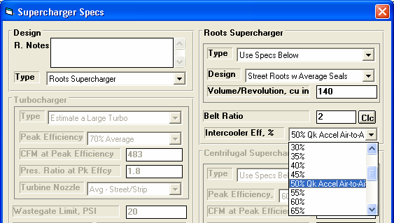
Figure A 19 New Features for Supercharger Specs
Now you can pick an Intercooler for a Roots Supercharger.
Larger section for Notes.
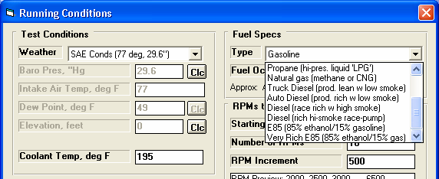
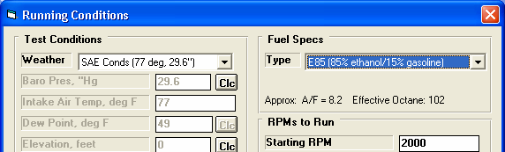
Figure A 20 New Features in Calculate Performance Running Conditions
Std and Plus versions both display the approximate A/F and Effective Octane the program will use. For some fuels, the program picks the Octane, like for E85, Alcohol (methanol), etc.
Plus Version has E85 Fuel Options.

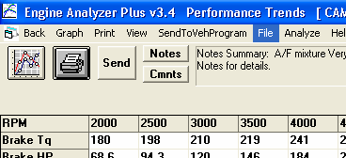
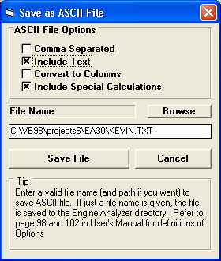
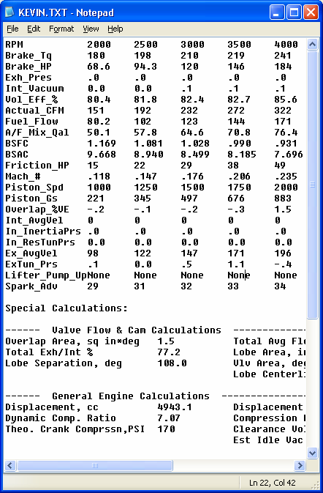
Figure A 21 New Features for Writing ASCII Data Files

Larger box for file name.
Plus Version has “Include Special Calcu-lations” option.
Note that this file includes the Special Calculations.
Here’s the file created with the options shown in the screen in the lower left corner opened up in Windows’ Notepad. This file could be easily printed or emailed to a friend to show Engine Analyzer results
New Browse button lets you more conveniently pick a file name and folder for your ASCII file. The program will also remember this information for the next time you write a file.
At the top of the Calculated Results, click on File for the screen shown in the lower left.

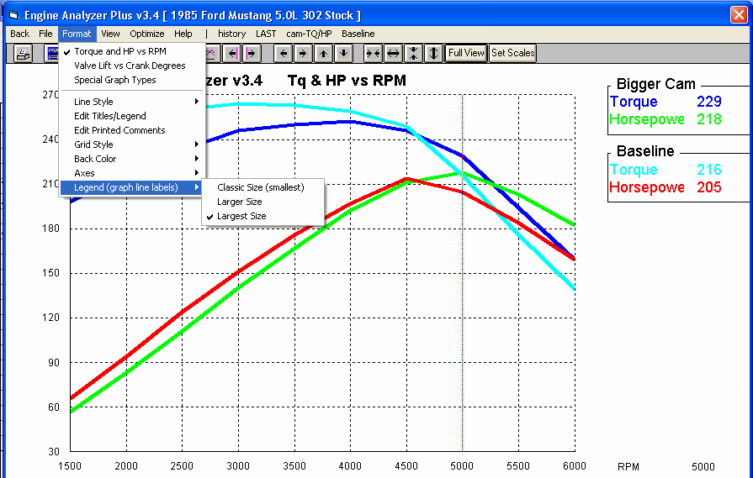
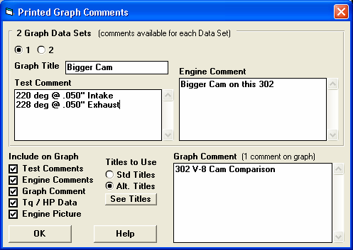
Figure A 22 New Features for Graphs Screen
Options and the Comment in this lower section apply to the whole graph. Figure A 23 shows a printout for the options picked here.
Choose option to display the different options available for each test being
Click on Edit Printed Comments for the screen of options shown below.
Legend shown in Largest Size font.
You can now pick to show the legend (labels on right side) in 3 different sizes of Fonts.

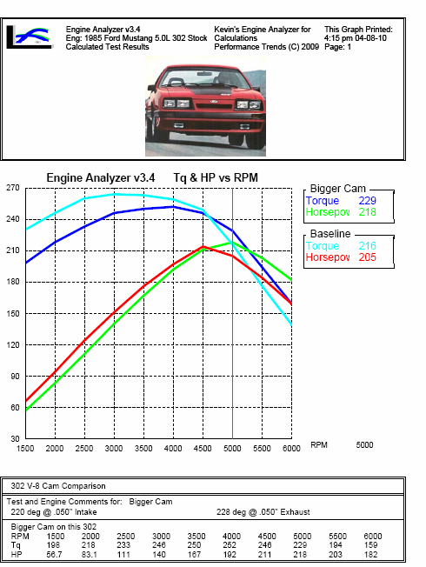
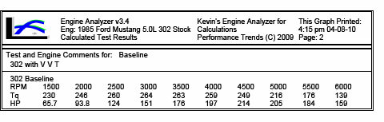
Figure A 23 Printed Graph with New Features

If you have a cursor line on the graph, the cursor line is now printed also. Values at the cursor are also printed in the legend.
Comments and data may continue onto a 2nd page as shown
Additional text and data printed at bottom of page, under graph, as selected in screen shown in Figure A 22.
Graphics file from Main Screen of Program
Company Logo graphics file (Plus version only)
2 lines of user entered text (Plus version only)

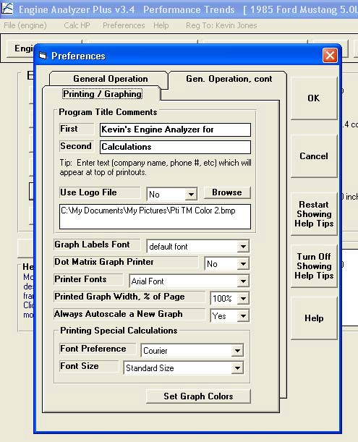
Figure A 24 New Preferences
This section “Program Title Comments” is available only in the Plus version, and lets you specify 2 lines of text and some graphics file (typically a company logo) to appear at the top of your printouts (reports and graphs).
New buttons to turn Off or turn On all intro help tips.

